incAccounting Deployment Steps

1. Build your .War file in NetBeans by clicking build. Take not of the path it built to.
2. Copy the .War file to svr2012-Web and place on desktop
3. Go to <https://www.internetworkconsulting.net:8181> and click on admin console from the web server
4. Go to Applications , then click Redeploy.
5. Browse for the newly built .War file and then click OK
6. When it is done processing, go to C:\glassfish4\glassfish\domains\domain1\applications\incAccounting\WEB-INF and then edit the web.xml file so that under configEditable it is set to true instead of false.  
   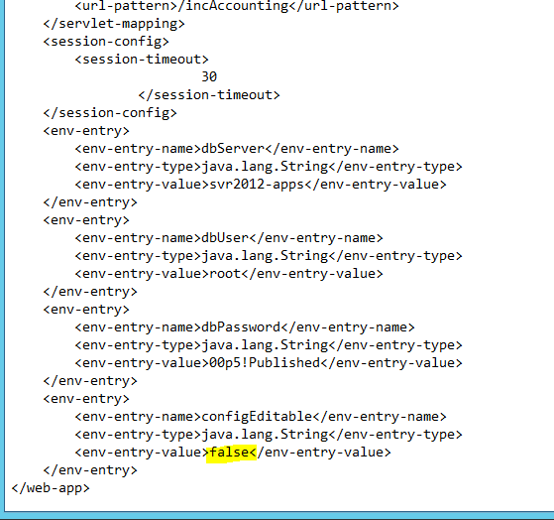
7. Go to the incAccounting login page and go to Database Setup
8. Update the database settings and test in order to save the connections
9. Return to the web.xml file and set it back to false.